Assignment 3: Retrieve data using Group By clause

create table Department(dept_id int identity(1,1) primary key,dept_name nvarchar(20))

create table Employee(emp_id int identity(1,1) primary key,

dept_id int foreign key references department(dept_id),

mngr_id int,

emp_name nvarchar(20),

salary float)

insert into Department values('.net'),

('Finanace'),

('networking')

,('java')

,('mobileapp')

,('devops')

insert into employee values ( 1,2001,'kayling',20000),

( 1,2001,'Tucker',24000),

( 2,2003,'blaze',30000),

( 2,2003,'ADELYN',35000),

( 3,2002,'ADloren',45000),

( 3,2002,'clare',40000),

( 4,2004,'scarlet',50000),

( 4,2004,'blackwidow',55000),

( 5,2005,'frank',60000),

( 5,2005,'fin',65000),

( 6,2006,'wade',70000),

( 6,2006,'vadebarett',75000)

Query 1): write a SQL query to find Employees who have the biggest salary in their Department

Sol: select d.dept_name as Department, e.emp_name as Employee, e.Salary

from Employee as e

join Department as d

on e.dept_id = d.dept_id

join (

select max(Salary) as Salary, dept_id

from Employee

group by dept_id

) as mx

on e.Salary = mx.Salary and e.dept_id = mx.dept_id

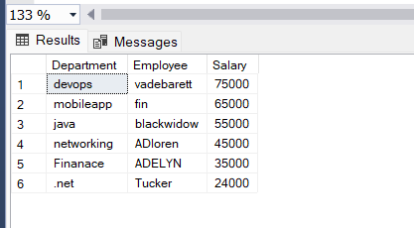

Query:2) write a SQL query to find Departments that have less than 3 people in it.

Solselect d.dept_name from Department d left join Employee e on

d.dept_id=e.dept_id group by d.dept_name having count(emp_id)<3

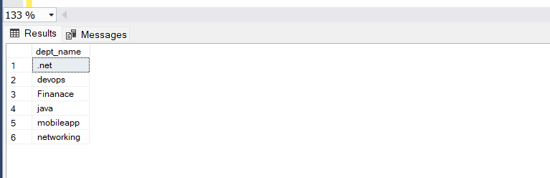

Query: 3) write a SQL query to find All Department along with the number of people there

Sol: select d.dept_name,count(emp_id) as Numberofpeople from Department d left join Employee e on

d.dept_id=e.dept_id group by d.dept_name

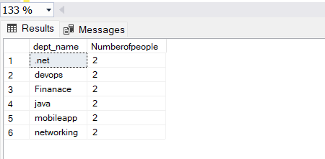

Query:4) write a SQL query to find All Department along with the total salary there

Sol: select d.dept_name,sum(salary) as TotalSalaryDepartment from Department d left join Employee e on

d.dept_id=e.dept_id group by d.dept_name

